**K-3566主板产品规格书**

**K-3566 Mainboard Specification**

|  |  |
| --- | --- |
| 版 本Version | V1.0 |
| 日 期 Date | 2021-11-28 |

敬告：本文档版权归内容原创公司所有，并保留一切权力。文档内容如有修改更新，请联系提供方获取最新版本，恕不另行通知。

Note: This document is copyrighted by the content original company and all rights reserved. If the contents of the document are updated, please contact the provider for the latest version without notice.

**修改记录 Changelog**

|  |  |  |
| --- | --- | --- |
| 1.0.0 | 2021-09-25 | 中英文合并版本。Chinese and English merged version. |
| 1.0.1 | 2021-10-12 | TTL/232/485兼容串口描述信息订正。TTL/232/485 compatible description correct. |
| 1.0.2 | 2021-11-28 | 规格清单中增加MIPI屏接口说明；订正J31信号定义。Add MIPI DSI panel list item. |

**目 录 Contents**

1 主芯片简介 RK3566 Brief 5

2 产品概述 Product Overview 6

3 规格清单 Specification List 8

4 接口定义 Interface definition 10

4.1 J1 RJ45千兆以太网口 RJ45 Gbit Ethernet Jack 10

4.2 J2 数据串口2 Data Serial Port 2 10

4.3 J3 数据串口0 Data Serial Port 0 10

4.4 J4 eDP输出FPC接口 eDP Output FPC Header 11

4.5 J5 m-PCIE 4G插座 m-PCIE 4G Socket 12

4.6 J6 MIPI屏FPC接口 MIPI Panel FPC Connector 13

4.7 J7 I2C FPC接口 I2C FPC Header 14

4.8 J8 Micro-SIM卡座 Micro-SIM Card Socket 14

4.9 J9 TF卡插座 TF Card Socket 14

4.10 J10 HDMI输入接口 HDMI Input Header 14

4.11 J11 数据串口3 Data Serial Port 3 15

4.12 J13 USB OTG接口 USB OTG Header 15

4.13 J14 SATA硬盘数据线插座 SATA Hard Disk Socket 16

4.14 J15 数据串口8 Data Serial Port 8 16

4.15 J16 电子墨水屏接口 E-Ink Panel FPC Connector 16

4.16 J17 MicroUSB插座 MicroUSB Socket 16

4.17 J18 USB 2.0接口 USB 2.0 Host Header 16

4.18 J19 USB 2.0接口 USB 2.0 Host Header 17

4.19 J20 SATA供电接口 SATA Power Supply Header 17

4.20 J21 DC-12V插座 DC-12V Socket 17

4.21 J22 USB 2.0接口 USB 2.0 Host Header 17

4.22 J23 USB 2.0接口 USB 2.0 Host Header 18

4.23 J24 数据串口4 Data Serial Port 4 18

4.24 J25 USB Type A插座 USB Type A Socket 18

4.25 J26 USB 3.0 Type A插座 USB 3.0 Type A Socket 18

4.26 J27 I2C总线接口 I2C Bus Header 19

4.27 J28 四段式耳麦插座 4-Pole HP/Mic Jack 19

4.28 J30 音频线路输出 Audio Line Output 19

4.29 J31 遥控-LED接口 Remote Control & LED Header 19

4.30 J32 USB 3.0接口 USB 3.0 Host Header 20

4.31 J33 喇叭接口 Speaker Header 20

4.32 J34 音频输入接口 Audio Input Header 21

4.33 J35 HDMI输出插座 HDMI Output Socket 21

4.34 J36 DC-12V输入接口 DC-12V Input Header 21

4.35 J37 LVDS电压接口 LVDS Voltage Header 21

4.36 J38 按键和开关接口 Keypad and Switch Header 22

4.37 J39 背光控制接口 Backlight Control Header 23

4.38 J41 LVDS接口 LVDS Header 23

4.39 J43 USB 2.0接口 USB 2.0 Host Header 23

4.40 J44 USB 2.0接口 USB 2.0 Host Header 24

4.41 SW1 烧录模式按键 Recovery Mode Button 24

5 物理尺寸 Physical Size 25

6 注意事项 Assembley Precautions 26

7 软件指南 Software Guide 28

# 主芯片简介 RK3566 Brief

RK3566芯片具备高性能、高扩展应用特点。目前为瑞芯微Rockchip产品线中高性价比的芯片，硬件规格在同配置竞品中处于领先地位。

* CPU：四核64位Cortex-A55架构，基于高端22nm工艺打造，主频最高1.8GHz。
* GPU：ARM Mali-G52 2EE，支持OpenGL ES 1.1/2.0/3.2，OpenCL 2.0，Vulkan 1.1，内嵌高性能2D加速硬件
* NPU：支持0.8Tops算力
* 多媒体：支持4K 60fps H.265/H.264/VP9视频解码；支持1080P 100fps H.265/H.264视频编码；支持8M ISP
* 显示：支持eDp/HDMI2.0/MIPI/LVDS/24bit RGB/T-CON和双屏同显
* 接口：支持USB2.0/USB3.0/PCIE2.0/SATA3.0/GMAC



# 产品概述 Product Overview

K-3566主板基于瑞芯微RK3566高性能大小核架构应用处理器平台，RK3566主芯片集成四核Cortex-A55、Mali-G52 2EE高性能GPU，主频最高可达1.8GHz，具备超强的计算性能、2D/3D图形处理能力和全高清视频编解码能力，完美支持4Kx2K@60fps超清解码和4Kx2K HDMI超清输出。

K-3566 mainboard is based on Rockchip RK3566 high-performance application processor platform. RK3566 is a low power, high performance processor for computing, personal mobile internet devices and other smart device applications. It integrates dual-core Cortex-A55 clocked at up to 1.8GHz, with superior computing performance, 2D/3D graphics processing capabilities and Full HD video codec capabilities. It perfectly supports 4Kx2K@60fps decoding and 4Kx2K HDMI output.

此款主板专门针对**超薄**应用进行严格选材和设计，紧凑的尺寸和丰富的接口方便其集成到整机中，为最终的产品带来流畅的体验和超强的性能，可应用于数字标牌、触摸互动、消费电子、娱乐系统等行业。

This mainboard is specially designed for **ultra-thin** applications with strict material selection and design. The compact size and rich interface facilitate its integration into the complete machine, bringing a smooth experience and superior performance to the final product. It can be applied to digital signage, touch interactive, consumer electronics, entertainment systems and other industries.

K-3566 V2.0主板实物照片接口示意图如下所示。

K-3566 V2.0 mainboard actual interface diagram as shown below.

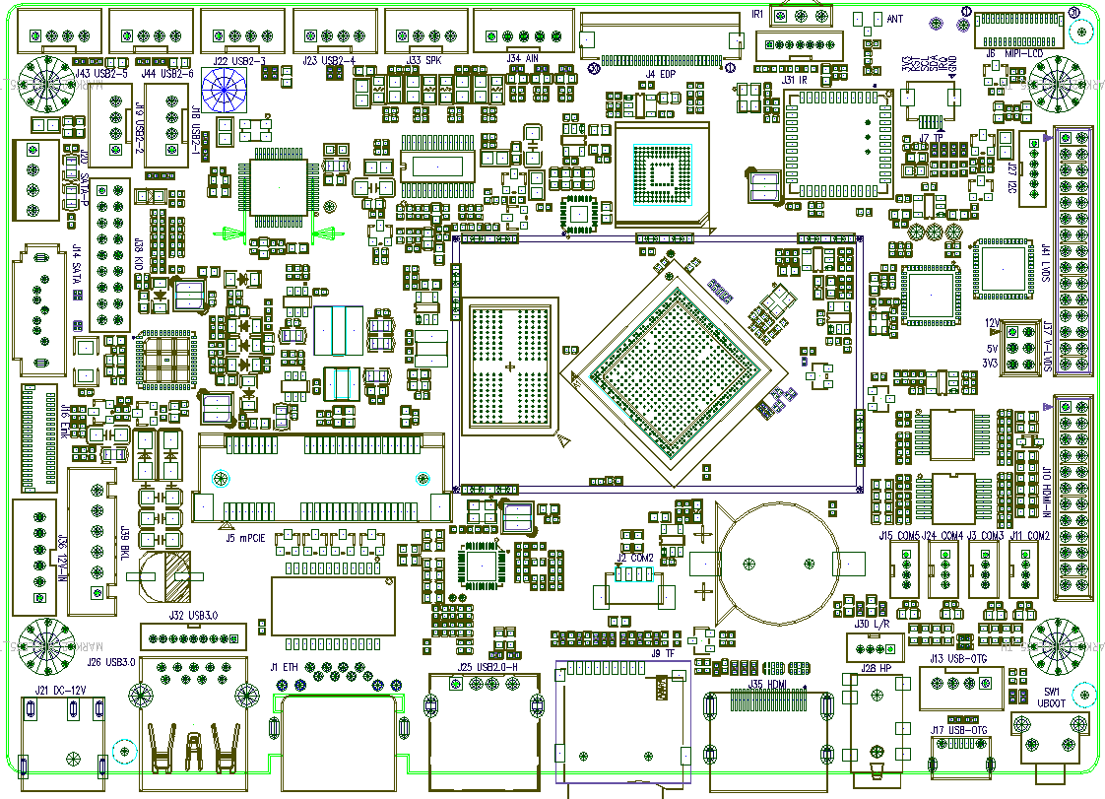

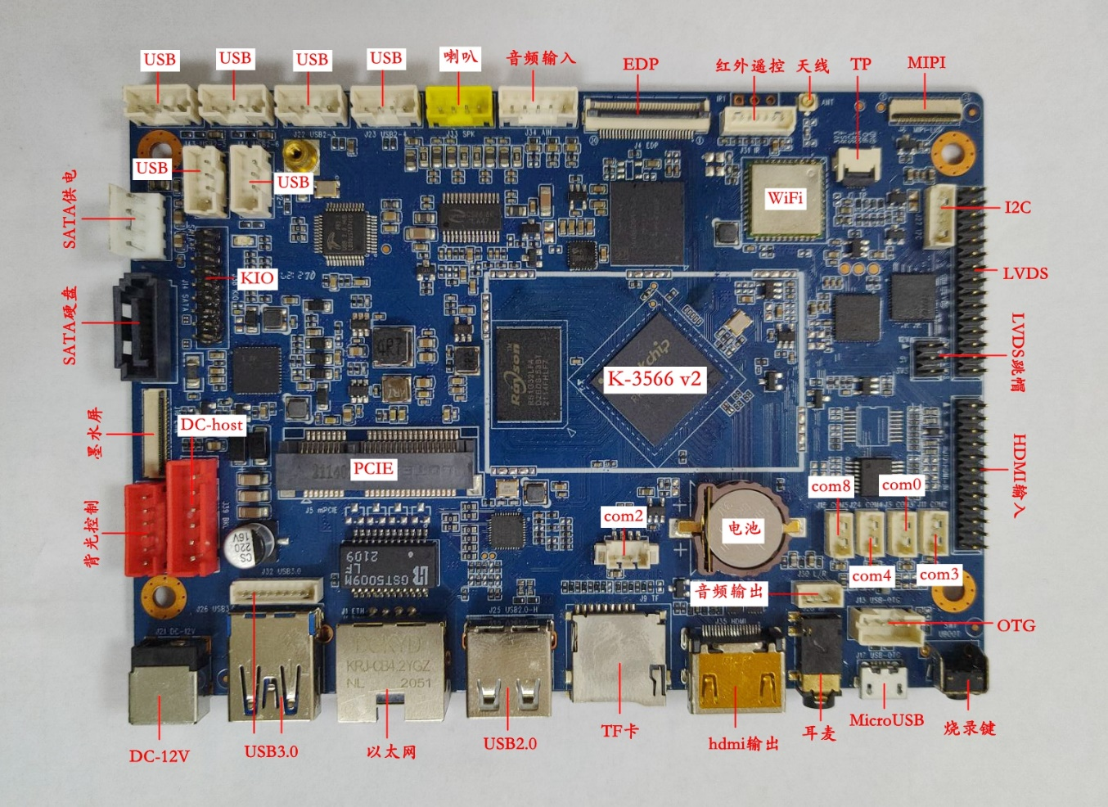

# 规格清单 Specification List

K-3566的系统功能和接口特性如下表所示。K-3566’s system functions and interface features are shown in the following table.

| **功能&接口**  **Function&Interface** | **详细描述**  **Detailed Description** |
| --- | --- |
| **CPU** | RK3566 Cortex-A55四核，最高主频1.8GHz  RK3566 Cortex-A55 dual-core, up to 1.8GHz |
| **DDR** | LPDDR4 2GB（4GB|8GB可选）  LPDDR4 2GB (4GB|8GB optional) |
| **存储·Storage** | 默认标配16GB EMMC NAND芯片，可扩展至最大128GB  The default comes with an 16GB EMMC NAND chip that can scale up to 128GB |
| **LVDS** | 30针行业标准双路LVDS接口，支持VESA/JEITA格式，最高支持1080P输出  30-pin industry-standard dual LVDS supporting VESA/JEITA format up to 1080P output |
| **MIPI-DSI** | 31-Pin FPC MIPI-DSI显示接口，最高支持1920x1200输出  31-Pin FPC MIPI-DSI display port supporting up to 1920x1200 |
| **HDMI输出**  **HDMI Output** | HDMI 2.0a标准显示接口，最高支持4K输出  HDMI 2.0a standard display interface supports up to 4K output |
| **HDMI输入**  **HDMI Input** | HDMI 1.4标准输入接口，支持720P和1080P信号  HDMI 1.4 standard video input interface supports 720P and 1080P signals |
| **EDP** | 30针FPC EDP接口，支持1~2通道模式，最高支持1920x1200输出  30-pin FPC EDP supporting 1~2 lanes format up to 1920x1200 output |
| **线路输出·Line Output** | 支持标准左右声道线路输出（排针接口+耳机接口）  Support standard left and right channel line output (pin header+headphone jack) |
| **功放输出**  **Amplifier output** | 8欧·6W双路音频功放输出  8 Ohm 6W Dual Audio Amplifier Output |
| **MIC输入**  **MIC Input** | 差分MIC输入（排针接口）  Differential MIC input (pin header) |
| **线路输入·Line Input** | 支持标准左右声道线路输入（排针接口）  Support standard left and right channel line input (pin header) |
| **USB接口**  **USB Interface** | 2个横插接口（USB 3.0x1和USB 2.0x1），7个内置排针（USB 3.0x1和USB 2.0x6）  2 horizontal connectors (USB 3.0x1 and USB2.0x1), 7 pin headers (USB 3.0x1 and USB 2.0x6) |
| **串口**  **Serial Port** | 1个TTL内置，4个TTL/232兼容内置（其中2个兼容485）  1 TTL, 4 TTL/232 compatible (2 485 compatible) |
| **TF卡**  **Micro SD Card** | 自弹式TF卡插座，最高支持128GB TF卡  Self-elastic micro SD card socket, up to 128GB capacity |
| **摄像头**  **Camera** | 支持800万像素以内USB摄像头  Support USB camera within 8 million pixels |
| **WiFi** | 内置高性能SDIO接口WiFi模块，支持IEEE 802.11 b/g/n/ac，默认配置单频2.4GHz  Built-in high performance SDIO interface WiFi module, support IEEE 802.11 b/g/n/ac |
| **蓝牙**  **Bluetooth** | 内置高性能串口BT模块，支持V2.1+EDR/BT v3.0/BT v3.0+HS/BT v4.0  Built-in high performance serial interface BT module with support for V2.1+EDR/BT v3.0/BT v3.0+HS/BT v4.0 |
| **以太网口**  **Ethernet** | 1路10/100/1000M自适应以太网RJ45网口  1 port 10/100/1000M Adaptive Ethernet RJ45 connector |
| **MiniPCI-E 4G** | 行业标准MiniPCI-E 4G模块接口  Industry standard MiniPCI-E 4G module interface |
| **背光控制**  **Baclight Control** | 1路行业标准液晶屏背光控制接口，支持背光开关和亮度调节  1 port Industry standard LCD backlight control header, support for backlight switch and brightness adjustment |
| **红外遥控**  **Infrared RC** | 标准红外遥控接收头和红外接收排针接口  Standard infrared remote control receiver and infrared receiver pin header |
| **GPIO信号**  **GPIO Signals** | 8路GPIO信号，可扩展GPIO按键和/或3.3V输入/输出  8-way GPIO signals for such as GPIO buttons and/or 3.3V digital input/output |
| **I2C总线**  **I2C Bus** | I2C排针和FPC接口，可扩展I2C电容屏等  I2C pin header and FPC for I2C capacitive screen and etc |
| **SATA硬盘**  **SATA HD** | 标准SATA 3.0硬盘接口（带电源排针）  Standard SATA 3.0 hard disk port with power supply header |
| **E-Ink墨水屏**  **E-Ink Panel** | 39针FPC E-Ink屏接口，支持常规2200x1650墨水屏  30-pin FPC E-Ink panel up to 2200x1650 output |
| **实时时钟**  **Real Time Clock** | 超低功耗RTC电路（带CR1220纽扣电池），并可支持定时开关机  Ultra-low-power RTC circuit (CR1220 battery) with timer and alarm functionalities |
| **指示灯**  **LED Indicator** | 红色待机指示和绿色工作指示灯  Red LED indicator for standby and green LED indicator for running |
| **按键**  **Buttons** | 烧录键（RECOVERY）和电源键  Recovery mode button and power switch button |
| **电源输入**  **DC Input** | 支持9~15V宽电压直流电源输入  Supports 9~15V wide voltage DC power input |
| **环境要求**  **Ambient Requirement** | 工作温度0°~70°，工作湿度0%~95%（不结露）  Working temperature 0°~70°, working humidity 0%~95% (non-condensing) |
| **物理尺寸**  **Physical Size** | 长*宽*高（135mm*95mm*9mm），**PCB正面高度7mm**  Length*Width*Heigjht (135mm*95mm*9mm), **PCB top side height 7mm** |
| **安卓系统**  **Android Version** | 推荐安卓11，可选Linux Buildroot/Debian 10/Ubuntu-18.04  Recommended Android 11，Linux Buildroot/Debian 10/Ubuntu-18.04 optional |

# 接口定义 Interface definition

## J1 RJ45千兆以太网口 RJ45 Gbit Ethernet Jack

【J1】RJ45千兆以太网口。[J1] RJ45 Gbit Ethernet Jack.

## J2 数据串口2 Data Serial Port 2

【J2】内置串口2（单排1.25mm-三角为1脚），只支持TTL电平；**对应的软件编程设备节点为ttyS2**。[J24] Built-in Serial Port 2 (SIP 1.25mm-Triangle is pin 1). The output level is only TTL. **The related software device node name is ttyS2**.

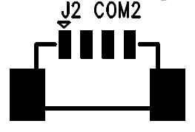

|  |  |  |
| --- | --- | --- |
| **Pin#** | **Definition** | **Note** |
| 1 | VCC | 电源输出（默认3.3V，可选5V）Power output (Default 3.3V, 5V option) |
| 2 | TX | 数据发送（仅TTL电平） Data transmit (Only TTL) |
| 3 | RX | 数据接收（仅TTL电平） Data receive (Only TTL) |
| 4 | GND | 数字地 Digital Ground |

注意：如需将调试串口作为数据串口使用，则请联系供应商获取定制版本软件；在上电的前5秒此串口会输出启动信息（上位机或下位机需要处理数据容错）。Note: If you need to use the debugging serial port as a data serial port, please contact the supplier to obtain the customized software; this serial port will output the startup information in the first 5 seconds of power on (the upper or lower machine should handle this kind of data fault tolerance).

## J3 数据串口0 Data Serial Port 0

【J3】内置串口0（单排1.25mm-方孔为1脚）,默认为RS-232电平且可配置为TTL电平（焊接U9833则为RS-232电平）；**对应的软件编程设备节点为ttyS0**。[J3] Built-in Serial Port 0 (SIP 1.25mm-Square pad is pin 1). The output level is RS-232 by default and it could be setup to TTL if required (RS-232 if U9833 mounted). **The related software device node name is ttyS0**.

|  |  |  |
| --- | --- | --- |
| **Pin#** | **Definition** | **Note** |
| 1 | GND | 数字地 Digital Ground |
| 2 | RX | 数据接收（TTL或RS-232） Data receive (TTL or RS-232 level) |
| 3 | TX | 数据发送（TTL或RS-232） Data transmit (TTL or RS-232 level) |
| 4 | VCC | 电源输出（默认3.3V，可选5V）Power output (Default 3.3V, 5V option) |

## J4 eDP输出FPC接口 eDP Output FPC Header

【J4】eDP屏FPC接口（FPC-0.35m 30-Pin**下接触**）。[J4] eDP Panel FPC Connector (FPC-0.5mm 30-Pin Bottom Contact).

|  |  |  |
| --- | --- | --- |
| **Pin#** | **Definition** | **Note** |
| 1 | NC | 未连接 Not Connected |
| 2 | GND | 数字地 Digital Ground |
| 3 | EDP_TX1N | TX1-差分数据输出 TX1- differential output |
| 4 | EDP_TX1P | TX1+差分数据输出 TX1+ differential output |
| 5 | GND | 数字地 Digital Ground |
| 6 | EDP_TX0N | TX0-差分数据输出 TX0- differential output |
| 7 | EDP_TX0P | TX0+差分数据输出 TX0+ differential output |
| 8 | GND | 数字地 Digital Ground |
| 9 | EDP_AUXP | AUX+差分辅助通道 AUX+ differential channel |
| 10 | EDP_AUXN | AUX-差分辅助通道 AUX- differential channel |
| 11 | GND | 数字地 Digital Ground |
| 12 | LCD_VCC | 逻辑电源（3.3V或5V） Logic Power (3.3V or 5V) |
| 13 | LCD_VCC | 逻辑电源（3.3V或5V） Logic Power (3.3V or 5V) |
| 14 | NC | 未连接 Not Connected |
| 15 | GND | 数字地 Digital Ground |
| 16 | GND | 数字地 Digital Ground |
| 17 | NC | 未连接 Not Connected |
| 18 | BL_GND | 背光LED地 Backlight LED Ground |
| 19 | BL_GND | 背光LED地 Backlight LED Ground |
| 20 | BL_GND | 背光LED地 Backlight LED Ground |
| 21 | BL_GND | 背光LED地 Backlight LED Ground |
| 22 | BL_EN | 背光使能 Backlight Enable |
| 23 | BL_PWM | 背光亮度PWM Backlight Brightness PWM |
| 24 | NC | 未连接 Not Connected |
| 25 | NC | 未连接 Not Connected |
| 26 | BL_POWER | 背光电源（12V） Backlight Power (12V) |
| 27 | BL_POWER | 背光电源（12V） Backlight Power (12V) |
| 28 | BL_POWER | 背光电源（12V） Backlight Power (12V) |
| 29 | BL_POWER | 背光电源（12V） Backlight Power (12V) |
| 30 | NC | 未连接 Not Connected |

**说明：eDP屏线可参考如下图片，常规的eDP屏均可使用反向的转接排线，具体请根据屏的手册确定。**

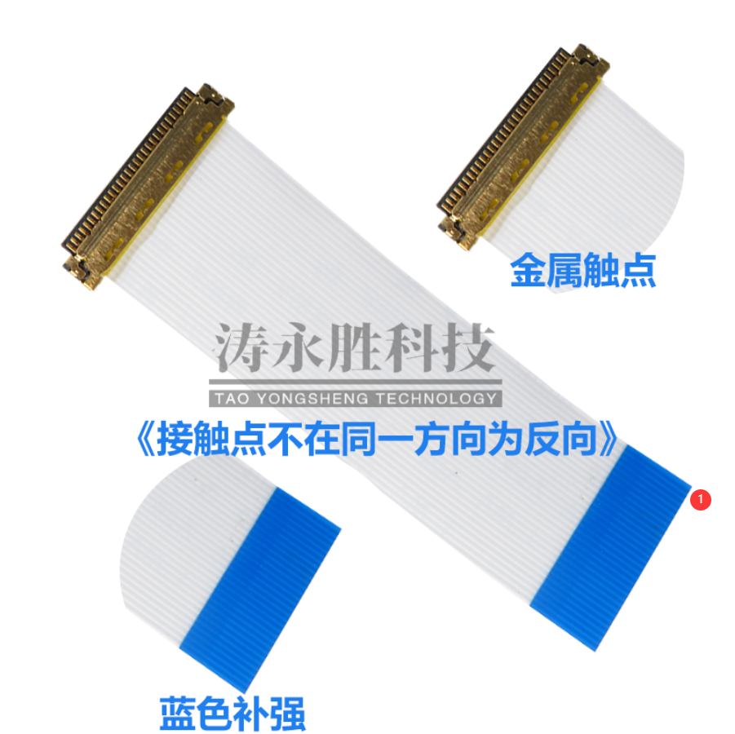

## J5 m-PCIE 4G插座 m-PCIE 4G Socket

【J5】标准m-PCIE 4G插座。[J5] Standard m-PCIE 4G Socket.

## J6 MIPI屏FPC接口 MIPI Panel FPC Connector

【J6】MIPI屏FPC接口（FPC-0.3mm 31-Pin**上/下接触**）。[J6] MIPI Panel FPC Connector (FPC-0.3mm 31-Pin Top/Bottom Contact).

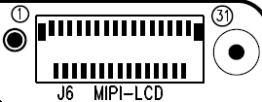

|  |  |  |
| --- | --- | --- |
| **Pin#** | **Definition** | **Note** |
| 1 | LED+ | LED阳极 LED Anode |
| 2 | LED+ | LED阳极 LED Anode |
| 3 | LED+ | LED阳极 LED Anode |
| 4 | NC | 未连接 Not Connected |
| 5 | LED- | LED阴级 LED Cathode |
| 6 | LED- | LED阴级 LED Cathode |
| 7 | LED- | LED阴级 LED Cathode |
| 8 | LED- | LED阴级 LED Cathode |
| 9 | GND | 数字地 Digital Ground |
| 10 | GND | 数字地 Digital Ground |
| 11 | MIPI_D2P | +MIPI差分数据输出 +MIPI differential lane2 |
| 12 | MIPI_D2N | -MIPI差分数据输出 -MIPI differential lane2 |
| 13 | GND | 数字地 Digital Ground |
| 14 | MIPI_D1P | +MIPI差分数据输出 +MIPI differential lane1 |
| 15 | MIPI_D1N | -MIPI差分数据输出 -MIPI differential lane1 |
| 16 | GND | 数字地 Digital Ground |
| 17 | MIPI_CKP | +MIPI差分时钟输出 +MIPI differential clock output |
| 18 | MIPI_CKN | -MIPI差分时钟输出 -MIPI differential clock output |
| 19 | GND | 数字地 Digital Ground |
| 20 | MIPI_D0P | +MIPI差分数据输出 +MIPI differential lane0 |
| 21 | MIPI_D0N | -MIPI差分数据输出 -MIPI differential lane0 |
| 22 | GND | 数字地 Digital Ground |
| 23 | MIPI_D3P | +MIPI差分数据输出 +MIPI differential lane3 |
| 24 | MIPI_D3N | -MIPI差分数据输出 -MIPI differential lane3 |
| 25 | GND | 数字地 Digital Ground |
| 26 | VDD-1V8 | 供电输出1.8V Power Supply 1.8V （默认不连接，需加焊R9232 0R） |
| 27 | RESET | 复位信号（1.8V电平） Reset Signal in 1.8V |
| 28 | GND | 数字地 Digital Ground |
| 29 | VDD-1V8 | 供电输出1.8V Power Supply 1.8V |
| 30 | VDD-3V3 | 供电输出3.3V Power Supply 3.3V |
| 31 | VDD-3V3 | 供电输出3.3V Power Supply 3.3V |

## J7 I2C FPC接口 I2C FPC Header

【J7】I2C总线接口（FPC-0.5mm前插后翻盖上下接触-三角为1脚）。[J7] I2C Bus Header (FPC-0.5mm Bottom Contact Triangle Pin-1).

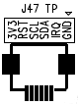

|  |  |  |
| --- | --- | --- |
| **Pin#** | **Definition** | **Note** |
| 1 | GND | 数字地 Digital Ground |
| 2 | IRQ | 中断输入（3.3V电平） Interrupt input (3.3V level) |
| 3 | SDA | I2C总线数据信号 I2C Bus data |
| 4 | SCL | I2C总线时钟信号 I2C Bus clock signal |
| 5 | RST | 复位输出（3.3V电平） Mainboard reset output (3.3V level) |
| 6 | 3V3 | 3.3V供电输出 Power output supply 3.3V |

## J8 Micro-SIM卡座 Micro-SIM Card Socket

【J8】Micro-SIM卡座。[J8] Micro-SIM Card Socket.

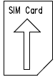

**注意：SIM卡座是常规中卡卡槽，插卡时请注意SIM卡缺口朝外插入。**

## J9 TF卡插座 TF Card Socket

【J9】标准TF卡插座。[J9] Standard TF Card Socket.

## J10 HDMI输入接口 HDMI Input Header

【J10】基于MIPI CSI方式的HDMI输入接口 （双排2.0mm-方孔为1脚）。[J10] HDMI input header based on MIPI CSI format [DIP 2.0mm-Square pad is pin 1].

|  |  |  |  |
| --- | --- | --- | --- |
| **Pin#** | **Definition** | **Pin#** | **Definition** |
| 1 | 5V | 2 | PON |
| 3 | GND | 4 | GND |
| 5 | MIPI_D0- | 6 | MIPI_D0+ |
| 7 | MIPI_D1- | 8 | MIPI_D1+ |
| 9 | MIPI_D2- | 10 | MIPI_D2+ |
| 11 | MIPI_D3- | 12 | MIPI_D3+ |
| 13 | MIPI_CLK- | 14 | MIPI_CLK+ |
| 15 | INT | 16 | STB |
| 17 | GND | 18 | RST |
| 19 | I2S_LRCK | 20 | I2S_SCLK |
| 21 | I2S_CLK | 22 | I2S_SDI |
| 23 | I2C_SDA | 24 | I2C_SCL |

## J11 数据串口3 Data Serial Port 3

【J11】内置串口3（单排1.25mm-方孔为1脚）,默认为TTL电平且可配置为RS-232或RS-485电平（焊接U62则为RS-232电平、焊接U67则为RS-485电平）；**对应的软件编程设备节点为ttyS3**。[J11] Built-in Serial Port 3 (SIP 1.25mm-Square pad is pin 1). The output level is TTL by default and it could be setup to RS-232 or RS-485 if required (RS-232 if U62 mounted, RS-485 if U67 mounted). **The related software device node name is ttyS3**.

|  |  |  |
| --- | --- | --- |
| **Pin#** | **Definition** | **Note** |
| 1 | GND | 数字地 Digital Ground |
| 2 | RX|A | 数据接收或A (TTL|RS-232|RS-485）Data receive (TTL|RS-232|RS-485) |
| 3 | TX|B | 数据发送或B (TTL|RS-232|RS-485）Data transmit (TTL|RS-232|RS-485) |
| 4 | VCC | 电源输出（默认3.3V，可选5V）Power output (Default 3.3V, 5V option) |

## J13 USB OTG接口 USB OTG Header

【J13】USB调试接口（单排2.0mm-方孔为1脚）,此接口仅用于进行系统烧录和ADB调试。[J13]USB ADB Header (SIP 2.0mm-Square pad is pin 1), this port should only be used as system burn or ADB connection.

|  |  |  |
| --- | --- | --- |
| **Pin#** | **Definition** | **Note** |
| 1 | GND | 数字地 Digital Ground |
| 2 | DP | USB差分数据+ USB Differential Data+ |
| 3 | DM | USB差分数据- USB Differential Data- |
| 4 | V5S | PC端提供5V供电 5V power supply from PC |

**注意：此端口为主芯片USB OTG口直通端口，信号和J17是同一组，两个不能同时接。**

## J14 SATA硬盘数据线插座 SATA Hard Disk Socket

【J14】SATA硬盘标准7芯数据线插座。[J14] SATA Hard Disk Standard 7-Pin Data Cable Socket.

## J15 数据串口8 Data Serial Port 8

【J15】内置串口15（单排1.25mm-方孔为1脚）,默认为RS-232电平且可配置为TTL电平（焊接U9833则为RS-232电平）；**对应的软件编程设备节点为ttyS8**。[J15] Built-in Serial Port 0 (SIP 1.25mm-Square pad is pin 1). The output level is RS-232 by default and it could be setup to TTL if required (RS-232 if U9833 mounted). **The related software device node name is ttyS8**.

|  |  |  |
| --- | --- | --- |
| **Pin#** | **Definition** | **Note** |
| 1 | GND | 数字地 Digital Ground |
| 2 | RX | 数据接收（TTL或RS-232） Data receive (TTL or RS-232 level) |
| 3 | TX | 数据发送（TTL或RS-232） Data transmit (TTL or RS-232 level) |
| 4 | VCC | 电源输出（默认3.3V，可选5V）Power output (Default 3.3V, 5V option) |

## J16 电子墨水屏接口 E-Ink Panel FPC Connector

【J16】电子墨水屏FPC接口（FPC-0.3mm 39-Pin**上/下接触**）。[J16] E-Ink Panel FPC Connector (FPC-0.3mm 39-Pin Top/Bottom Contact).

## J17 MicroUSB插座 MicroUSB Socket

【J17】USB 2.0 MicroUSB插座。[J17] USB 2.0 MicroUSB Socket.

**注意：J17和J13接口为信号复用，只能同时接其中一个。**

## J18 USB 2.0接口 USB 2.0 Host Header

【J18】USB 2.0接口（单排2.0mm-方孔为1脚）。[J18] USB 2.0 Host Header (SIP 2.0mm-Square pad is pin 1)

|  |  |  |
| --- | --- | --- |
| **Pin#** | **Definition** | **Note** |
| 1 | GND | 数字地 Digital Ground |
| 2 | DP0 | USB差分数据+ USB Differential Data+ |
| 3 | DM0 | USB差分数据- USB Differential Data- |
| 4 | 5V | 5V输出 Power output 5V |

## J19 USB 2.0接口 USB 2.0 Host Header

【J19】USB 2.0接口（单排2.0mm-方孔为1脚）。[J19] USB 2.0 Host Header (SIP 2.0mm-Square pad is pin 1)

|  |  |  |
| --- | --- | --- |
| **Pin#** | **Definition** | **Note** |
| 1 | GND | 数字地 Digital Ground |
| 2 | DP0 | USB差分数据+ USB Differential Data+ |
| 3 | DM0 | USB差分数据- USB Differential Data- |
| 4 | 5V | 5V输出 Power output 5V |

## J20 SATA供电接口 SATA Power Supply Header

【J20】SATA供电接口（单排2.5mm-方孔为1脚）。[J20] SATA Power Supply Header (SIP 2.5mm-Square pad is pin 1)

|  |  |  |
| --- | --- | --- |
| **Pin#** | **Definition** | **Note** |
| 1 | 12V | 12V输出 Power output 12V |
| 2 | GND | 电源地 Power Ground |
| 3 | GND | 电源地 Power Ground |
| 4 | 5V | 5V输出 Power output 5V |

**注意：此接口12V和5V最大输出电流不超过1A，对于3.5寸大硬盘如果出现供电不足则建议外接电源供电！**

## J21 DC-12V插座 DC-12V Socket

【J21】DC-12V电源插座，内正外负，内芯直径2.0mm，外圈孔径5.5mm。[J21] DC-12V power socket, positive outer and negative inner, inner pin diameter 2.0mm, outer ring diameter 5.5mm.

## J22 USB 2.0接口 USB 2.0 Host Header

【J22】USB 2.0接口（单排2.0mm-方孔为1脚）。[J22] USB 2.0 Host Header (SIP 2.0mm-Square pad is pin 1)

|  |  |  |
| --- | --- | --- |
| **Pin#** | **Definition** | **Note** |
| 1 | GND | 数字地 Digital Ground |
| 2 | DP0 | USB差分数据+ USB Differential Data+ |
| 3 | DM0 | USB差分数据- USB Differential Data- |
| 4 | 5V | 5V输出 Power output 5V |

## J23 USB 2.0接口 USB 2.0 Host Header

【J23】USB 2.0接口（单排2.0mm-方孔为1脚）。[J23] USB 2.0 Host Header (SIP 2.0mm-Square pad is pin 1)

|  |  |  |
| --- | --- | --- |
| **Pin#** | **Definition** | **Note** |
| 1 | GND | 数字地 Digital Ground |
| 2 | DP0 | USB差分数据+ USB Differential Data+ |
| 3 | DM0 | USB差分数据- USB Differential Data- |
| 4 | 5V | 5V输出 Power output 5V |

## J24 数据串口4 Data Serial Port 4

【J24】内置串口4（单排1.25mm-方孔为1脚）,默认为RS-485电平且可配置为RS-232或TTL电平（焊接U62则为RS-232电平、焊接U9832则为RS-485电平）；**对应的软件编程设备节点为ttyS4**。[J24] Built-in Serial Port 4 (SIP 1.25mm-Square pad is pin 1). The output level is RS-485 by default and it could be setup to RS-232 or TTL if required (RS-232 if U62 mounted, RS-485 if U9832 mounted). **The related software device node name is ttyS4**.

|  |  |  |
| --- | --- | --- |
| **Pin#** | **Definition** | **Note** |
| 1 | GND | 数字地 Digital Ground |
| 2 | RX|A | 数据接收或A (TTL|RS-232|RS-485）Data receive (TTL|RS-232|RS-485) |
| 3 | TX|B | 数据发送或B (TTL|RS-232|RS-485）Data transmit (TTL|RS-232|RS-485) |
| 4 | VCC | 电源输出（默认3.3V，可选5V）Power output (Default 3.3V, 5V option) |

## J25 USB Type A插座 USB Type A Socket

【J25】标准USB 2.0 Type A插座。[J25] USB Type A Socket.

**注意：此USB接口为CPU内部独立端口，需要高带宽和性能要求的USB设备可以接到此接口，比如USB高拍仪或高清摄像头等。**

## J26 USB 3.0 Type A插座 USB 3.0 Type A Socket

【J26】标准USB 3.0 Type A插座。[J26] USB 3.0 Type A Socket.

**注意：J26和J32接口为信号复用，只能同时接其中一个。**

## J27 I2C总线接口 I2C Bus Header

【J27】I2C总线接口（单排1.25mm-方孔为1脚）。[J27] I2C Bus Header (SIP 1.25mm-Square pad is pin 1).

|  |  |  |
| --- | --- | --- |
| **Pin#** | **Definition** | **Note** |
| 1 | 3.3V | 3.3V供电输出 Power output supply 3.3V |
| 2 | SCL | I2C总线时钟信号 I2C Bus clock signal |
| 3 | SDA | I2C总线数据信号 I2C Bus data |
| 4 | IRQ | 中断输入（3.3V电平） Interrupt input (3.3V level) |
| 5 | RST | 复位输出（3.3V电平） Mainboard reset output (3.3V level) |
| 6 | GND | 数字地 Digital Ground |

## J28 四段式耳麦插座 4-Pole HP/Mic Jack

【J28】四段式3.5mm耳机/麦克风插座（CTIA美标定义-如下图），信号和J5/J15一致，支持耳机插入喇叭静音。[J28] 4-Pole 3.5mm Headphone&Micphone Jack (CTIA Standard jack). It is the same signals with J5/J15. It support insert dection for speaker mute.

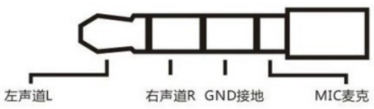

## J30 音频线路输出 Audio Line Output

【J30】音频线路输出（单排1.25mm-方孔为1脚）。[J30] Audio Line Output (SIP 1.25mm-Square pad is pin 1).

|  |  |  |
| --- | --- | --- |
| **Pin#** | **Definition** | **Note** |
| 1 | DET | 耳机检测信号 Headphone detect signal |
| 2 | AR | 立体声输出右声道 Stereo output right channel |
| 3 | GND | 音频地 Audio Ground |
| 4 | AL | 立体声输出左声道 Stereo output left channel |

## J31 遥控-LED接口 Remote Control & LED Header

【J31】遥控-LED接口（单排1.25mm-方孔为1脚）。[J31] Remote Control & LED Header (SIP 1.25mm-Square pad is pin 1).

|  |  |  |
| --- | --- | --- |
| **Pin#** | **Definition** | **Note** |
| 1 | 5VS | 5V Standby供电输出 Power output 5V standby |
| 2 | GND | 数字地 Digital Ground |
| 3 | IR | 5V电平红外遥控输入信号 5V level Irda remote control input singal |
| 4 | IO | 3.3V电平GPIO输入信号 3.3V level GPIO input signal |
| 5 | GREEN | 运行指示灯信号（外接绿灯） Running indicator for external green LED |
| 6 | 5VS | 5V Standby供电输出 Power output supply 5V standby |
| 7 | RED | 待机指示灯信号（外接红灯） Standby indicator for external red LED |

## J32 USB 3.0接口 USB 3.0 Host Header

【J32】USB 3.0接口（单排1.25mm-面对缺口左侧为1脚）。[J32] USB 3.0 Host Header (SIP 1.25mm-Square pad is pin 1)

|  |  |  |
| --- | --- | --- |
| **Pin#** | **Definition** | **Note** |
| 1 | TX+ | USB差分数据TX+ USB Differential Data TX+ |
| 2 | TX- | USB差分数据TX- USB Differential Data TX- |
| 3 | GND | 数字地 Digital Ground |
| 4 | RX+ | USB差分数据RX+ USB Differential Data RX+ |
| 5 | RX- | USB差分数据RX- USB Differential Data RX- |
| 6 | GND | 数字地 Digital Ground |
| 7 | D+ | USB差分数据+ USB Differential Data+ |
| 8 | D- | USB差分数据- USB Differential Data- |
| 9 | 5V | 5V输出 Power output 5V |

**注意：J32和J26接口为信号复用，只能同时接其中一个。**

## J33 喇叭接口 Speaker Header

【J33】喇叭接口（单排2.0mm-方孔为1脚）。[J33] Speaker Header (SIP 2.0mm-Square pad is pin 1).

|  |  |  |
| --- | --- | --- |
| **Pin#** | **Definition** | **Note** |
| 1 | OUTP_R | 喇叭右声道+ Speaker right channel + |
| 2 | OUTN_R | 喇叭右声道- Speaker right channel - |
| 3 | OUTN_L | 喇叭左声道- Speaker left channel - |
| 4 | OUTP_L | 喇叭左声道+ Speaker left channel + |

## J34 音频输入接口 Audio Input Header

【J34】音频输入接口（单排2.0mm-方孔为1脚）。[J34]Audio inut header (SIP 2.0mm-Square pad is pin 1).

|  |  |  |
| --- | --- | --- |
| **Pin#** | **Definition** | **Note** |
| 1 | GND | 音频地 Audio Ground |
| 2 | MIC | 单声道麦克风输入 Mono microphone input |
| 3 | RIN | 线路输入右声道 Line input right channel |
| 4 | GND | 音频地 Audio Ground |
| 5 | LIN | 线路输入左声道 Line input left channel |

## J35 HDMI输出插座 HDMI Output Socket

【J35】标准HDMI输出插座。[J35] Standard HDMI Output Socket.

## J36 DC-12V输入接口 DC-12V Input Header

【J36】DC-12V输入接口（单排2.54mm-方孔为1脚）。[J36] DC-12V Input Header (SIP 2.54mm-Square pad is pin 1).

|  |  |  |
| --- | --- | --- |
| **Pin#** | **Definition** | **Note** |
| 1 | 12V | 直流电源输入（9~15V）DC Power Input (9~15V) |
| 2 | 12V | 直流电源输入（9~15V）DC Power Input (9~15V) |
| 3 | GND | 电源地 Power Ground |
| 4 | GND | 电源地 Power Ground |
| 5 | V5S | 5V待机电源输入 5V Standby Power Input |
| 6 | STB | 待机信号输出（低电平待机） Standby Enable Output (0V for Standby) |

## J37 LVDS电压接口 LVDS Voltage Header

【J37】LVDS驱屏跳线接口（双排2.0mm-方孔为1脚）。1和2脚跳线帽短接则J41的VLCD为12V，3和4脚跳线帽短接则J41的VLCD为5V，5和6脚跳线帽短接则J41的VLCD为3.3V。请根据实际使用的液晶屏的逻辑电压调整跳线帽位置，注意不要跳错位置否则会造成液晶屏和主板电路的损坏。

[J37]LVDSVoltage Header (DIP 2.0mm-Square pad is pin 1). If pin 1 and 2 are jumper shorted, the VLCD of J41 is 12V. If pin 3 and 4 are jumper shorted, the VLCD of J41 is 5V. If pin 5 and 6 are jumper shorted, the VLCD of J41 is 3.3V. Please adjust the jumper position according to the actual logic voltage of the LCD screen. Be careful not to jumper to the wrong position or it may damage the LCD screen and the motherboard circuit.

## J38 按键和开关接口 Keypad and Switch Header

【J38】按键和开关接口（双排2.0mm-方孔为1脚）。[J38]Keypad and Switch header (DIP 2.0mm-Square pad is pin 1).

|  |  |  |  |
| --- | --- | --- | --- |
| **Pin#** | **Definition** | **Pin#** | **Definition** |
| 1 | 3V3 | 2 | LED+ |
| 3 | GND | 4 | LED- |
| 5 | RES- | 6 | PW+ |
| 7 | RES+ | 8 | PW- |
| 9 | K1 | 10 | K2 |
| 11 | K3 | 12 | K4 |
| 13 | GND | 14 | GND |
| 15 | K5 | 16 | K6 |
| 17 | K7 | 18 | K8 |

如下图所示：6和8脚外接轻触开关，短按开关屏、长按开关机（需软件支持）；5和7脚外接轻触开关可以实现按键复位；2和4脚可以接LED灯实现工作指示（LED信号电压经过了内部分压，如果无法点亮则可用1和3脚直接做电源指示）。K1音量+、K2音量-、K3休眠/唤醒、K4-返回、K5-HOME（需软件支持），K6~K8自定义。

如果将K1~K8开放为GPIO使用则相应的编号为K1=#56、K2=#23、K3=#57、K4=#5、K5=#58、K6=#146、K7=#59、K8=#115。

As shown below: Pin 6 and 8 as short press to turn screen on or off and long press to power down (software support required); Pin 5 and 7 as reboot; Pin 2 and 4 as LED indicator ( or use pin1 and 3 directly). K1 as Volume Up, K2 as Volume Down, K3 as Sleep/Wake, K4 as Return, K5 as HOME (software support required), K6 ~ K8 as cutomized signal.



## J39 背光控制接口 Backlight Control Header

【J39】背光控制接口（单排2.0mm-方孔为1脚）。[J39] Backlight Control Header (SIP 2.0mm-Square pad is pin 1).

|  |  |  |
| --- | --- | --- |
| **Pin#** | **Definition** | **Note** |
| 1 | 12V | If the current exceeds 2A, external 12V is recommended |
| 2 | 12V | 如果电流超过2A则建议外接12V供电 |
| 3 | EN | 默认输出5V The default output is 5V |
| 4 | ADJ | 3.3V方波（1KHz频率）3.3V square wave (1KHz Freq.) |
| 5 | GND | 电源地 Power Ground |
| 6 | GND | 电源地 Power Ground |

## J41 LVDS接口 LVDS Header

【J41】双路LVDS接口 （双排2.0mm-方孔为1脚）。[J41] Dual LVDS header [DIP 2.0mm-Square pad is pin 1].

|  |  |  |  |
| --- | --- | --- | --- |
| **Pin#** | **Definition** | **Pin#** | **Definition** |
| 1 | VLCD | 2 | VLCD |
| 3 | VLCD | 4 | GND |
| 5 | GND | 6 | GND |
| 7 | RXO0- | 8 | RXO0+ |
| 9 | RXO1- | 10 | RXO1+ |
| 11 | RXO2- | 12 | RXO2+ |
| 13 | GND | 14 | GND |
| 15 | RXOC- | 16 | RXOC+ |
| 17 | RXO3- | 18 | RXO3+ |
| 19 | RXE0- | 20 | RXE0+ |
| 21 | RXE1- | 22 | RXE1+ |
| 23 | RXE2- | 24 | RXE2+ |
| 25 | GND | 26 | GND |
| 27 | RXEC- | 28 | RXEC+ |
| 29 | RXE3- | 30 | RXE3+ |

## J43 USB 2.0接口 USB 2.0 Host Header

【J43】USB 2.0接口（单排2.0mm-方孔为1脚）。[J43] USB 2.0 Host Header (SIP 2.0mm-Square pad is pin 1)

|  |  |  |
| --- | --- | --- |
| **Pin#** | **Definition** | **Note** |
| 1 | GND | 数字地 Digital Ground |
| 2 | DP0 | USB差分数据+ USB Differential Data+ |
| 3 | DM0 | USB差分数据- USB Differential Data- |
| 4 | 5V | 5V输出 Power output 5V |

## J44 USB 2.0接口 USB 2.0 Host Header

【J44】USB 2.0接口（单排2.0mm-方孔为1脚）。[J44] USB 2.0 Host Header (SIP 2.0mm-Square pad is pin 1)

|  |  |  |
| --- | --- | --- |
| **Pin#** | **Definition** | **Note** |
| 1 | GND | 数字地 Digital Ground |
| 2 | DP0 | USB差分数据+ USB Differential Data+ |
| 3 | DM0 | USB差分数据- USB Differential Data- |
| 4 | 5V | 5V输出 Power output 5V |

## SW1 烧录模式按键 Recovery Mode Button

【SW1】直插烧录小按键，先按住且保持然后上电约3秒后松开则进入烧录模式。[SW1] On-board recovery mode button. First press and then hold for about 3-second while power on will enter the recovery mode.

# 物理尺寸 Physical Size

PCB大小为135mm*95mm，固定孔直径3.0mm，相应的物理尺寸参数如下图所示。如需详细尺寸信息请咨询厂家索取DXF档文件。

The PCB size is 135mm*95mm and the fixing hole diameter is 3.0mm. The corresponding physical size parameters are shown in the figure below. For detailed size information, please consult the manufacturer for DXF file.

# 注意事项 Assembley Precautions

K-3566主板组装和使用时请注意以下关键事项：Please note the following key points when using the K-3566 mainboard:

1. 本产品相对湿度：10%～90％，无凝露。Relative humidity of this product: 10% to 90%, no condensation.
2. 本产品工作温度：0°~70°。The working temperature of this product: 0°~70°.
3. 本产品存储温度：-40°~70°。This storage temperature of this product: -40 ° ~ 70 °.
4. 整机装配和运输过程中需做防静电处理。Anti-static treatment is required during assembly and transportation of this product.
5. 本板接口连接线缆不可过长，否则可能会影响信号质量。The board interface connection cable must not be too long. Otherwise, the signal quality may be affected.
6. 整机装配时严禁使板子受到扭曲或重压而变形。Never allow the board to be distorted or heavily stressed during assembly.
7. 严禁裸板与其他外设之间发生短路。Do not short circuit between mainboard and other peripherals.
8. 外接LVDS或eDP液晶屏时，注意驱屏电压和电流是否符合要求，且注意屏线插座1脚方向。When connecting to external LVDS or eDP LCD screen, pay attention to whether the screen voltage and current meet the requirements, and pay attention to the screen connector pin-1 direction.
9. 外接LVDS或eDP液晶屏时，注意背光电压和电流是否符合要求。**液晶屏背光功率在20W以上则建议使用单独的电源板进行背光供电**。When connecting to external LVDS or eDP LCD screen, pay attention to whether the backlight voltage and current meet the requirements.
10. 外接接口（USB、GPIO、串口、I2C、SPI、HDMI等）外接设备时，注意外设的IO电平和电流是否符合要求。**使用主板接插件上的电源管脚给外设供电时，常规电源脚电流严禁超过100mA、USB电源脚电流严禁超过500mA**。串口连接外设时还需要电平匹配（3.3V TTL电平、RS-232电平和RS-485电平）。When connecting to peripherals using USB, GPIO, Serial, I2C, SPI, HDMI, etc., pay attention to whether the IO voltage level and current of the peripheral meet the requirements. When using the power pin on these connectors to supply power to the external circuit, the regular power pin must not exceed 100mA, and the USB power pin must not exceed 500mA.
11. 主板输入电源请务必接入电源输入接口或插座，并根据总外设评估整板电流是否符合要求；**严禁为了方便操作从背光插座接口直接给主板供电**。Please connect the power to the power input socket or connector, and evaluate whether the current of the whole board meets the requirements according to the total peripherals. It is strictly forbidden to directly supply power from the backlight connector.
12. 通信模块部分距离金属壳体至少5毫米，避免信号受到干扰。The communication module should be mounted at least 5mm away from the metal housing to avoid signal interference.

# 软件指南 Software Guide

K-3566主板内部串口和扩展串口软件端口号如下：

|  |  |
| --- | --- |
| **端口Port** | **软件设备节点Software Device Node** |
| J3 | /dev/ttyS0 |
| J2 | /dev/ttyS2 |
| J11 | /dev/ttyS3 |
| J24 | /dev/ttyS4 |
| J15 | /dev/ttyS8 |
|  |  |